**Lab Assignment 1: Explore IoT simulation tools.**

**Group no -13 D20B**

1. **Description of tool, advantages and disadvantages**
2. Tinkercad-

Tinkercad is an online platform that provides tools for 3D design, electronics, and coding. It is primarily aimed at beginners, students, and educators who want to learn and experiment with 3D modeling, electronics, and programming in a user-friendly environment. Here are some advantages and disadvantages of Tinkercad:

Advantages:

* User-Friendly: Tinkercad is known for its user-friendly interface. It's easy to learn and navigate, making it accessible for users with little to no prior experience in 3D design or electronics.
* No Installation Required: Tinkercad is entirely web-based, so users don't need to download or install any software. It can be accessed from any device with an internet connection and a modern web browser.
* 3D Design: Tinkercad's 3D design tools are suitable for creating basic to moderately complex 3D models. Users can design objects and prototypes for 3D printing, which is useful for makers and educators.
* Electronics Simulations: Tinkercad offers a virtual electronics lab where users can build and simulate electronic circuits. This is a valuable resource for learning about electronics without the need for physical components.
* Coding Integration: Tinkercad includes a code block editor based on Scratch, which enables users to learn and practice coding by creating interactive projects.
* Educational Resources: Tinkercad provides educational materials, tutorials, and projects suitable for classroom use. It's a valuable tool for educators teaching STEM (Science, Technology, Engineering, and Mathematics) subjects.

Disadvantages:

* Limited Complexity: While Tinkercad is excellent for beginners, it may not be suitable for advanced users or professionals looking for highly sophisticated 3D design or electronics simulation capabilities. It has limitations in terms of complexity.
* Online Dependency: Tinkercad's reliance on an internet connection means that users need to be online to use it. This can be a drawback in situations where internet access is limited or unreliable.
* Not Suitable for Advanced Projects: If you have advanced 3D design or electronics projects with specific requirements, you may find Tinkercad lacking in terms of customization and advanced features.
* Limited Export Options: Tinkercad's export options may not be as versatile as more advanced 3D modeling or electronics simulation software. It might not support certain file formats or advanced features needed for specific applications.

1. Wokwi-

Wokwi was a platform for simulating and prototyping electronic circuits and microcontroller-based projects. Here are some advantages and disadvantages of Wokwi:

Advantages:

* Browser-Based: Wokwi is entirely web-based, which means you can access it from any device with an internet connection and a web browser. This makes it convenient and platform-independent.
* Circuit Simulation: Wokwi allows users to create, simulate, and test electronic circuits virtually. This is beneficial for learning electronics, testing circuit designs, and experimenting with components.
* Microcontroller Simulation: Wokwi supports various microcontrollers, including popular ones like Arduino, ESP8266, and ESP32. Users can write and test code for these microcontrollers in an online environment.
* Code Editor Integration: Wokwi offers code editors that are integrated with the circuit simulation. You can write code, upload it to the virtual microcontroller, and see the real-time effects on the simulated circuit.
* Educational Resource: Wokwi provides a range of educational resources, tutorials, and example projects suitable for students, educators, and hobbyists interested in electronics and microcontroller programming.
* Community and Sharing: Users can share their projects with others in the Wokwi community and collaborate on open-source hardware and software projects.

Disadvantages:

* Limited Complexity: Like many online simulation tools, Wokwi may have limitations in terms of the complexity of circuits and projects it can handle. It may not be suitable for very complex or advanced designs.
* Dependency on the Platform: Being a web-based platform, Wokwi relies on an internet connection. If you have a slow or unreliable internet connection, this could affect your experience.
* Evolution and Updates: Online platforms can evolve rapidly, and new features or changes can occur. It's essential to stay up-to-date with the latest features and changes in Wokwi if you rely on it for your projects.
* Limited Export Options: Depending on your needs, Wokwi may have limitations when it comes to exporting your projects or designs to other software or hardware platforms.

1. **Screenshots of simulation-**
2. TinkerCad

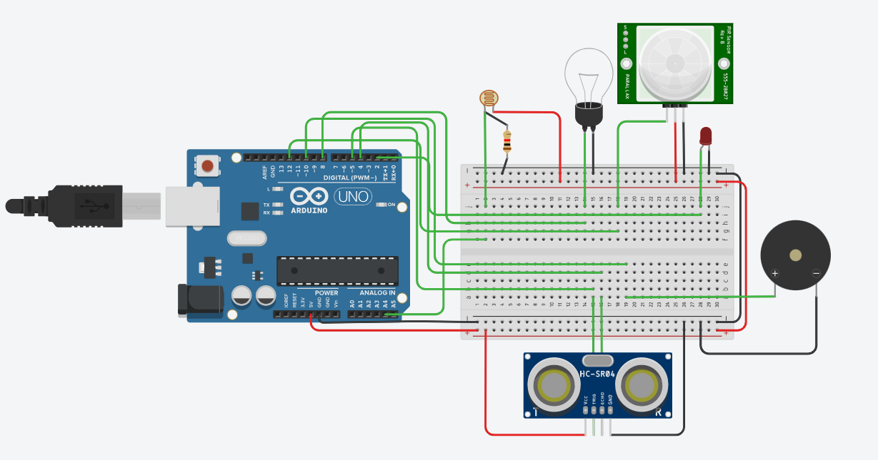

1. Wokwi

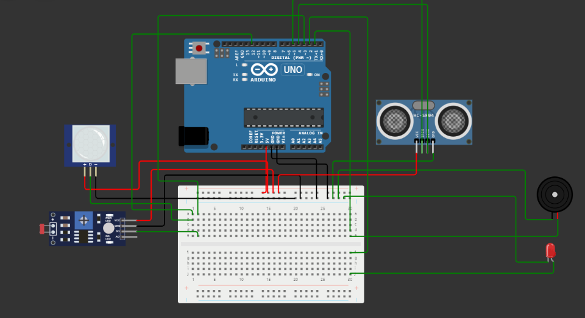

3. Results of simulation-

